Lesson 14 : Éyósthet – entertainment
Sqwal 1
to … | …-ing
léq’áleq’el | léq’leq'áleq’el | travel
ewólem te helme’áls pó:l | íwólem te helme’áls pó:l | play soccer
táy | tátey | race a canoe
éweltí:l | óweltí:l | race (any, foot, horse)
ó:lh | *** | get aboard (canoe, car, conveyance)
yeló:lh | *** | travel by canoe, car, airplane, any vehicle
tl’xwét | tl’xtl‘éxwet | compete
tl'xwéleq | tl'xwtl'xwéleq | win
lehá:l | lelehá:l | play slahal
lílehá:l | *** | gamble
qw'eyílex | qw'eyél:ex | dance
pepo:l | *** | play with a ball, play ball

Sqwal 2
táyōwelh | *** | racing canoe
slehá:l | *** | gambling sticks, slahal game
pó:l | *** | ball
lesák | lelesák | a bag
sq'émél | sq’emq’émel | paddle
q'exwōwelh | *** | war canoe
pút | pelúpt | boat
lhólhekw mashíl | *** | airplane
hikw shxwelólh | *** | bus

Sqwéltel
tl’xtl’éxwettset lí kw’e Xwlhémi yeláw t’óqwtem | We’re competing in Lummi next week.
tl'xwéleq yutl’ólem. | They won.
mekw’ ó:lh yutl'ólem. | They all got in/aboard.
Le ó:lh te Tom li te híkw shxwelólh kyó. | Tom was taking the bus.
yeló:lh te sléxwelh | He’s going by canoe.
yeló:lh te kyós. | He’s going with his car.
yeló:lh tel táyowelh. táyteytsel | I am in my racing canoe. I’m racing
kwútes te pól. | He took the ball.
tsel kwút te lesak. | I took the bag.
látsel óweltì:l. | I’m going racing
lelehá:ltset mekw‘ st‘óqw’tems | We’re playing slahal every weekend.
xwe’ít kw’e stax̱welh? pepó:l á:lhtel. | what are the kids doing? They are playing ball.
xwe’ít ta’ ts’exwelmexw? Iwolem helme’als pol. | what is your family doing? They are playing soccer.
Líchexw lheq'élexw kw'as ewólem te helme’als pol? | Do you know how to play soccer?
òweltí:l tútl’ò | he is/was racing.
Tewát te táyewelh? | Whose racing canoe is this?
Tewat te’ile sq’emq’émel? | Whose paddles are these here?
Tl’o swatset sq’emq’émel. | These are our paddles.
Tl’o l swa pol | That’s my (own) ball.
Tl’o aswa táyewelh | that’s your (own) racing canoe
Tl’o swas táyewelh | that’s his/hers/their (own) racing canoe
Tl’o swatset pelúpt | These are our boats.
Tl’o aswá’elep táyewelh | that’s your folks’ (own) racing canoe

iaqtem te sqwal 1
leq'leq’áleq’el | travelling | intransitive
present /past  progressive | singular | plural
1st person (I / we) | leq'leq’áleq’el tsel | leq'leq’áleq’eltset
2nd person (you / y'all) | leq'leq’áleq’el chexw | leq'leq’áleq’el chap
3rd person (she, he, it / they) | leq'leq’áleq’el | leq'leq’áleq’el

iaqtem te sqwal 2
leq'leq’áleq’el | travelling | intransitive
past (ambiguous)  progressive | singular | plural
1st person (I / we) | tsel leq'leq’áleq’el | tset leq'leq’áleq’el
2nd person (you / y'all) | chexw leq'leq’áleq’el | chap leq'leq’áleq’el
3rd person (she, he, it / they) | le leq'leq’áleq’el | le leq'leq’áleq’el

iaqtem te sqwal 3
leq'leq’áleq’el | travelling | intransitive
past progressive | singular | plural
1st person (I / we) | ilhtsel leq'leq’áleq’el | ilhtset leq'leq’áleq’el
2nd person (you / y'all) | ilhchexw leq'leq’áleq’el | ilhchap leq'leq’áleq’el
3rd person (she, he, it / they) | ilh leq'leq’áleq’el | ilh leq'leq’áleq’el

iaqtem te sqwal 4
leq'leq’áleq’elcha | will be travelling | intransitive
future progressive | singular | plural
1st person (I / we) | leq'leq’áleq’el tselcha | leq'leq’áleq’el tsetcha
2nd person (you / y'all) | leq'leq’áleq’el chexwcha | leq'leq’áleq’el chapcha
3rd person (she, he, it / they) | leq'leq’áleq’el cha | leq'leq’áleq’el cha

Halqeméylem 2, S’íwes 14 Skwix
Partner sqwal 1 swáyel

Iwesá:ls: Ask your partner what they did last weekend

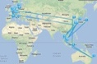Example 1: A: ilhchexw xwe’it tem t'oqw'temelh?
C: ilhtsel leq’áleq’el tem t'oqw'temelh.

Example 2: A: lilhchexw ewolem te helme’als pol tem t'oqw'temelh?
C: éwetsel il ewolem te helme’als pol tem t'oqw'temelh. Ewe tsel il éystexw ewolem te helme’als pol!

 | léq’áleq’el | 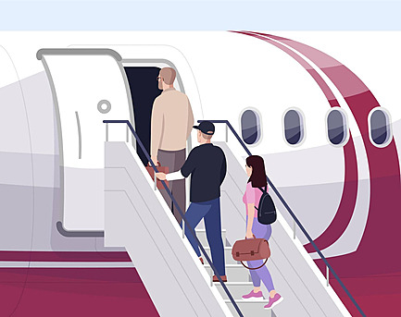 | ó:lh | 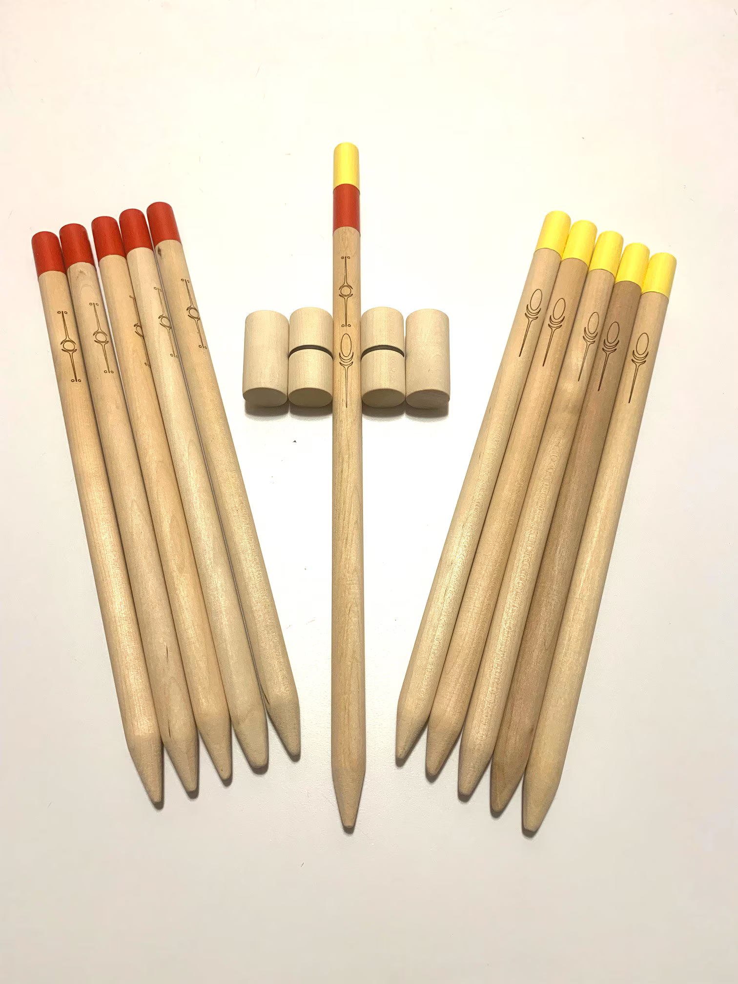 | lehà:l
 | ewólem te helme’áls pó:l | 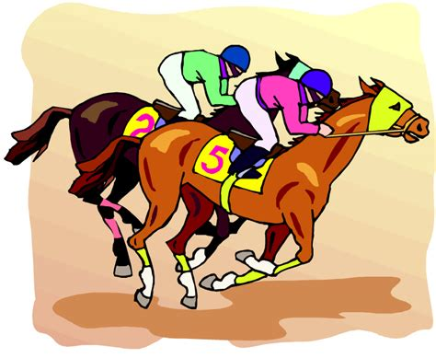 | éweltí:l |  | lílehà:l
 | táy | 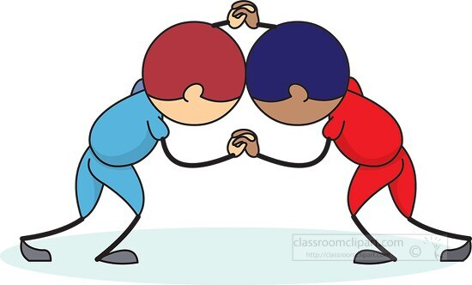 | tl’xwét |  | qw'eyílex
 |  |  | tl'xwéleq

1. | 7.
2. 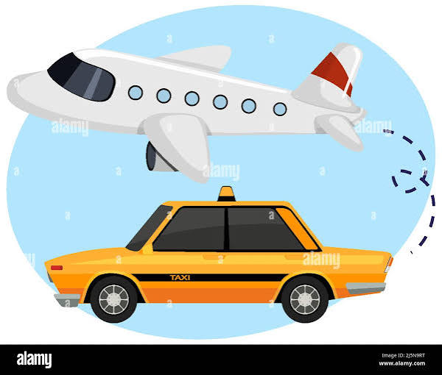 | 8.
3. | 9.
 | 10.
5. | 11.
6.
Halqeméylem 2, S’íwes 14 Skwix
Partner sqwal 2 swáyel

Iwesá:ls: Ask your partner what they need for next weekend
Example 1: A: li a stl’í kw’e táyewelh xwelam kw’e s’toqw’tems?
C: a’a, l stl’í kw’e táyowelh.


Example 2: A: li a stl’í kw’e pól xwelam kw’e s’toqw’tems?
C: ewe l’stl’í kw’e pól, l stl’i kw’e put!

 | táyowelh | 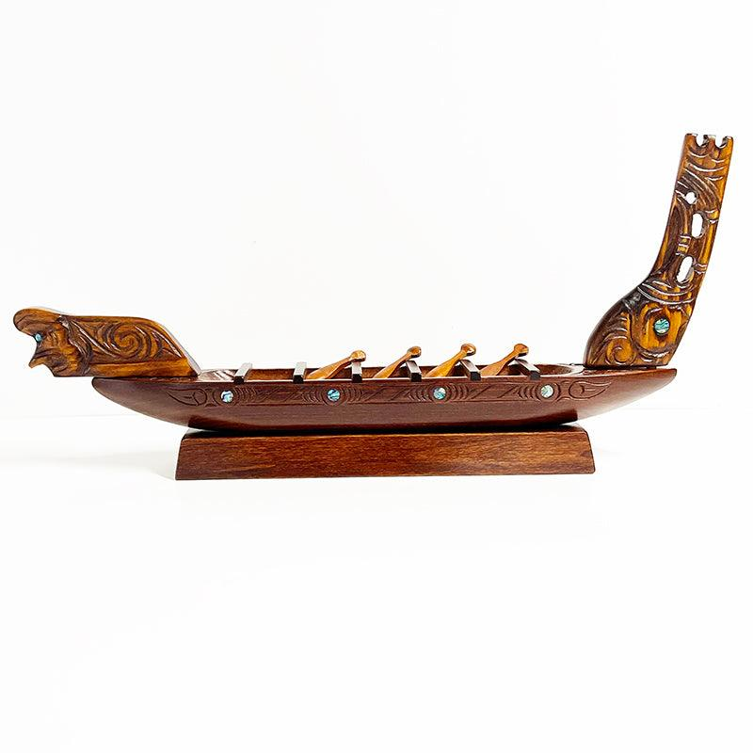 | q'exwō:welh
 | slehà:l |  | put
 | pó:l |  | lhólhekw meshil
 | lesák |  | hikw shxwelólh kyo
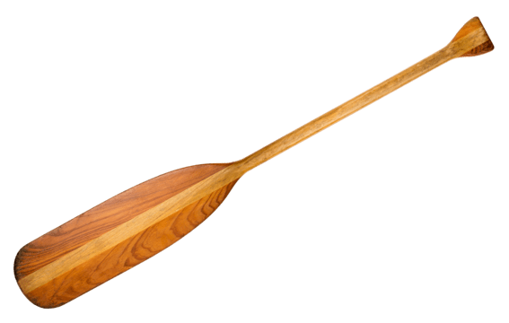 | sq'émél

Halqeméylem 2, S’íwes 14 Skwix
Partner grammar 1 swáyel

Iwesá:ls: With your partner, practice the following conversation, according to the guide below
A. líchexwcha leq'leq’áleq’el te s‘tóqw’tems?
C. éwe, ilhtsel ulh leq'leq’áleq’el tem t'oqw'temelh

Example:
- Lícha leq'leq’áleq’el tl’ Pít qes tl’ Mali ?
C. a’a, ilh leq'leq’áleq’el yutl’ólem tem t'oqw'temelh.

1. talhlímelh | 6. Sulisulwut
 | 
2. talhléwep | 7. Swolésiya qas te Sotmietel
 | 
3. ta'á'altha | 8. teléwe
 | 
4. ye stáxwelh | 9. tel siyáye qes ta'á'altha
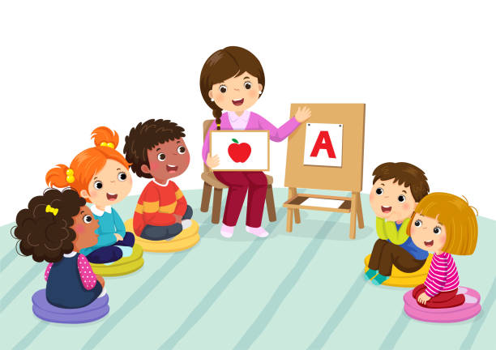 | 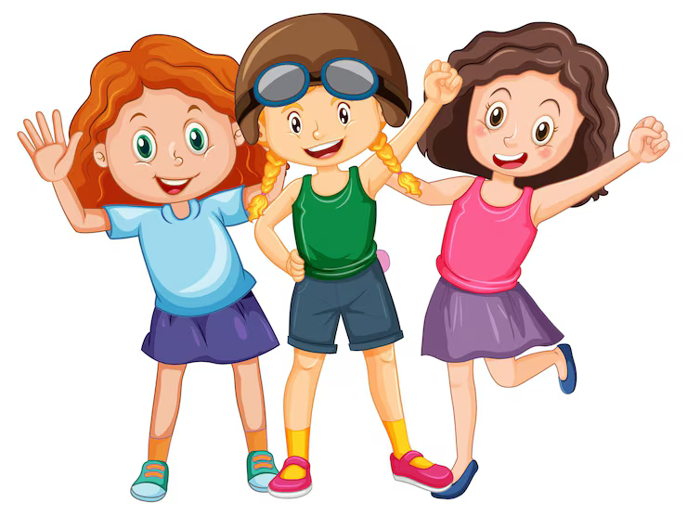
5. ta’ ts’elhxwelmexw | ta’ shxwemlíkw
 | 
Halqeméylem 2, S’íwes 14 Skwix
Qwulqweltel swáyel

Listen to, Read and Translate the dialoge with a partner. Re-enact and then switch roles.

A: láw Susal!
B: Láw Pít. Chexw xwe’ít o?
A: oh, tselcha leq’áleq’el. tl’xtl’éxwettset lí kw’e Xwlhémi yeláw t’óqwtem. Yelólh tel kyo kw’els lam. Mestexwtsel tel sq’emq’emel, qe mestexw tel táyowelh tl’ Semeonsiya.
B: Lichexw éystexw kw’as lam te pekcha’awtxw tloqays?
A: a’a, eystexwtsel. Petámetselcha tl’ Semeonsiya welís éystexws kw’s láms thútl’ó.

B Qe xwel qwóqwel i te shxwtatí:m. Welh shílekw kw'es lámtset we is hó:y telí te shxwtatí:m.
A Yéthesttselcha tútl'ó kw'es ówthets.
B Lew iyólem. Iyóthet te pékcha tés te sth'ó:kws.

Translation:
Hi Susan,
Hi Pete, What’s up?
Oh. I am going to travel. I’m competing in Lummi next week. Im going by car, but semeonsiya is bringing my canoe
Do you want to go to the movies?
Yes U want to. I will ask Semenonsiya if she wants to go.
But she’s still talking on the phone.
We're ready to go if she gets off the phone.
I'm going to tell her to hurry.
It's okay. The picture starts at seven o'clock.

Halqeméylem 2, S’íwes 14 Skwix
Grammar Worksheet swáyel

Iwesá:ls fill in the blank with the most appropriate form of travel/travelling/will travel prompted by the halq’eméylemqel in parentheses. Then translate the entire line to halq’eméylemqel.

A: leq’áleqel/ leq'leq’áleq’el

- ___ leq'leq’áleq’el tsel ____tloqáys kw’els ewólem the helme’als pol (I am traveling)
Xwelítemqel: I am traveling now to play soccer

- Ilh__tset leq’áleq’el ___kw’es tl’exwetset (We traveled)
Xwelítemqel: We traveled to compete.

- ___leq’áleq’elchexwcha ___yelólh kw’e pút wáyeles (You will travel)
Xwelítemqel: You will travel by boat tomorrow.

- Wiyóth kw’s___ leq'leq’áleq’elchap ___kw’s tl'exwtólap. (Y’all are travelling)
Xwelítemqel: Y’all are traveling for gambling quite often

- Qelát o ___leq’áleqel ___tútl’o A:yeqels. (he traveled)
Xwelítemqel: Again transformer travelled.

- ___leq’áleq’elcha___ thútl’o yelólh kw’e lholhekw’ meshil. (she will travel)
Xwelítemqel: She will travel by airplane.

- ___le leq’áleq’el qe éwe is tl’xwéleq. (they travelled)
Xwelítemqel: they traveled last week but they didn’t win.

- _Leq’áleq’eltselcha__yelólh kw’e hikw shxwelólh te st’áy. (I will travel)
Xwelítemqel: I will travel by bus to the race.

- ___ leq'leq’áleq’el tset ___lhe'a te témexw tset. (We are travelling)
Xwelítemqel:. We are traveling around on our land.

- Lí __chexw leq’áleq’el __ yewal yeló:lh kw’e hikw shxwelólh qeyálh kw’e put? (You travelled)
Xwelítemqel: Did you travel first by bus and then by boat?

