Lesson 18: animals 2
vocabulary
sq'átl' | *** | otter
swatíya | swewatíya | porcupine
speláwél | *** | mole
láqleqem | *** | goldeneye duck
ts'ésqel | *** | golden eagle
skoyám | *** | wolverine
shxwémetsel | *** | fisher
x̱óqel | *** | marten
sqwíqw | *** | groundhog
steqóye | stelqóye | wolf
sqáyéx̱ | *** | mink
pú:s | pelups | cat
púpso:llh | *** | kitten
th'éx̲tel | th'éx̲th'éx̲tel | rattlesnake
pítxel | petpítxel | Lizard
Sqweltel 1

li ts'íts'etxel te pítxel? | Does a lizard have short legs/is a lizard short legged?
a’a, ts'íts'etxel te pítxel. | Yes, a lizard is short legged.
li ts'íts'etxel te pú:s? | Is a cat short-legged?
éwe is ts'íts'etxel te pú:s. | No, a cat is not short legged.

Sqweltel 2
li tl’aqt te stl'ep'élets te steqóye? | Does the wolf have a long tail? (is it long the tail of the wolf?)
a’a, tl’aqt te stl'ep'élets te steqóye. | Yes, the wolf has a long tail.
li tl’aqt te stl'ep'élets te speláwéls? | Does a mole have a long tail?
Ewe is tl’aqt te stl'ep'élets te speláwéls. | A mole doesn’t have a long tail. (it is not long the tail of the mole)

Sqweltel 3
li t’óp’els te láqleqems? | Does a goldeneye duck have a beak? (is there a beak of the goldeneye duck)
a’a, t’óp’els te láqleqems. | Yes, a a goldeneye duck has a beak.
li t’óp’els te skoyáms? | Does a wolverine have a beak?
ewéta t’óp’els te skoyáms. | a wolverine doesn’t have a beak (it’s nothing the beak of a wolverine)

Sqweltel 4
li qw'x̲wéltses te púpso:lhs? | Does a kitten have claws?
qw'x̲wéltses te púpso:lhs. | yes a kitten has claws.
li qw'x̲wéltses te th'éx̲tels? | Does a rattlesnake have claws?
ewéta qw'x̲wéltses te th'éx̲tels. | No a rattlesnake doesn’t have claws.

Sqweltel 5
líchexw kw’etslexw te q’óyits lil sxelxcha? | Did you see the Moose I hunted?
lí kw’etslexwes te tl’elqtéle lil sxelxcha? | Did he see the deer I hunted?
litchap kw’etslexw te skoyám lil sxelxcha? | Did you folks see the wolverine I hunted?

Iyáqtem te sqwal
kw'átset | look at / examine something, someone
past/present  control transitive | singular | plural
1st person (I / we) | kw'átsettsel | kw'átsettset
2nd person (you / y'all) | kw'átsetchexw | kw'átsetchap
3rd person (she, he, it / they) | kw'átsetes | kw'átsetes

éwe is kw'átset | not look at / examine something, someone
Negative past/present  control transitive | singular | plural
1st person (I / we) | éwetsel kw'átsetal | éwetset kw'átsetet
2nd person (you / y'all) | éwechexw kw'átsetexw | éwechap kw'átsetap
3rd person (she, he, it / they) | éwe kw'átsetes | éwe kw'átsetes

Examples:
tsel kw’átset te pús st‘ets’á te lálem |  |  | I looked at the cat on top of the house.
kw’átsetes te hikw pítxel ta’ sqwíqemáy osu stl’is tútl’o kw’es halp’exes. |  |  | The big lizard looked at your little dog and wanted to eat it.
Iyólem kw'as kw'átset te syó:ys tl'oqáys? |  |  | Can you look at the work now?
Tés te skw'í:ls kw'as kw'átset te tókte? |  |  | what time did you see the doctor?
La kw'átsetes álhtel the siyólexwe slháli. |  |  | they went to see an old woman
kw’átsetses te spáth te syiyóqwem. |  |  | Bear looked out at the sun,
kw'átsetlha! |  |  | look at it!
kw'átsethòx |  |  | look at me, examine me, see me
skw'áy kw'els kw'átset te pípe |  |  | I can’t see/read the paper.
kw'étslexw | to see/glimpse someone,something, catch sight of someone
past/present  non-control transitive | singular |  |  | plural
1st person (I / we) | kw'étslexwtsel |  |  | kw'étslexwtset
2nd person (you / y'all) | kw'étslexwchexw |  |  | kw'étslexwchap
3rd person (she, he, it / they) | kw'étslexwes |  |  | kw'étslexwes

ewe kw'étslexwes | not to see/glimpse someone, something, catch sight of someone
negative past/present  non-control transitive | singular | plural
1st person (I / we) | éwetsel kw'étslexwal | éwetset kw'étslexwet
2nd person (you / y'all) | éwechexw kw'étslexwexw | éwechap kw'étslexwap
3rd person (she, he, it / they) | éwe kw'étslexwes | éwe kw'étslexwes

Remember that you can form negatives another way, with the helper/auxiliary verb i/li which you are very familiar with:
Éwetsel il kw'étslexw/kw’átset, éwechexw ixw kw'étslexw/kw’átset, ewe is kw'étslexw/kw’átset, ewetset it kw'étslexw/kw’átset, éwechap ip kw'étslexw/kw’átset

examples
éwe ílhtsel kw’étslexwal kw'e cheláqelhelh. | I didn’t see him/her yesterday.
kw'étslexwtsel kw’e th'éx̲tel qes tsel xwémxálem. | I saw a rattle snake and I ran away.
kw’étslexwes ye púpso:llh siq te sox̱weláwtxw. | They saw some kittens under the barn.
éwe kw'étslexwes thutl’ó kw’e sq'átl'. kw'étslexwes kw’e x̱óqel. | She didn't see am otter. She saw a marten.
skw'áy kw'a's kw'étslexw. | You can’t see it
kw'étslexwes yutl’ólem. | He saw them.
ewéta kw'e kw'étslexwes te swíyeqe | The man saw nothing.
luw iyó:lem kw'es kw'étslexwtset. | (it’s alright) we can see it.
luw iyó:lem kw'es kw'étslexwelep. | (it’s alright) you folks can see it.
Tselcha kw'étslóme qelát. | I’ll see you again.
Líchexw kw'étslexw tel kopú? | Did you see my coat?
Kw'étslexwes te í te x̲áx̲a Shxwelí. | The great Spirit saw this.
Li kw’etslexwes te tl’elqtéle lil sxelxcha? | Did he see the deer I hunted?
líchexw kw’etslexw te q’óyits lil sxelxcha? | Did you see the Moose I hunted?
kw'étslexwes te sth'óqwi li te tl'ép te qó | they saw fish deep in the water

Grammar note:
You use kw’átset when you have agency or control over the looking, that is, you do the looking on purpose. When you run into a friend or manage to see a wild animal, you use the word kw’étslexw. Both have the same root from ‘see’, but one has an -et ending, indicating control or agency the other has a -lexw ending, indicating non-control or ‘happenstance’.

Vocabulary 1
Instructions With your partner, ask and answer questions about animals. Follow the model.

example 1: A: li tl’aqt te stl'ep'élets te steqóye?
C: a’a, tl’aqt te stl'ep'élets te steqóye.

example 2: A: li tl’aqt te stl'ep'élets te speláwéls?
C: Ewe is tl’aqt te stl'ep'élets te speláwéls.

(don’t forget the -s at the end of the animal word!)
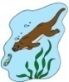 | sq'átl' |  |  | shxwémetsel |  | 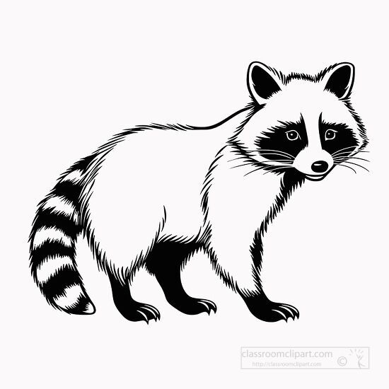 | mél:és
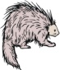 | swatíya / swatíya |  | 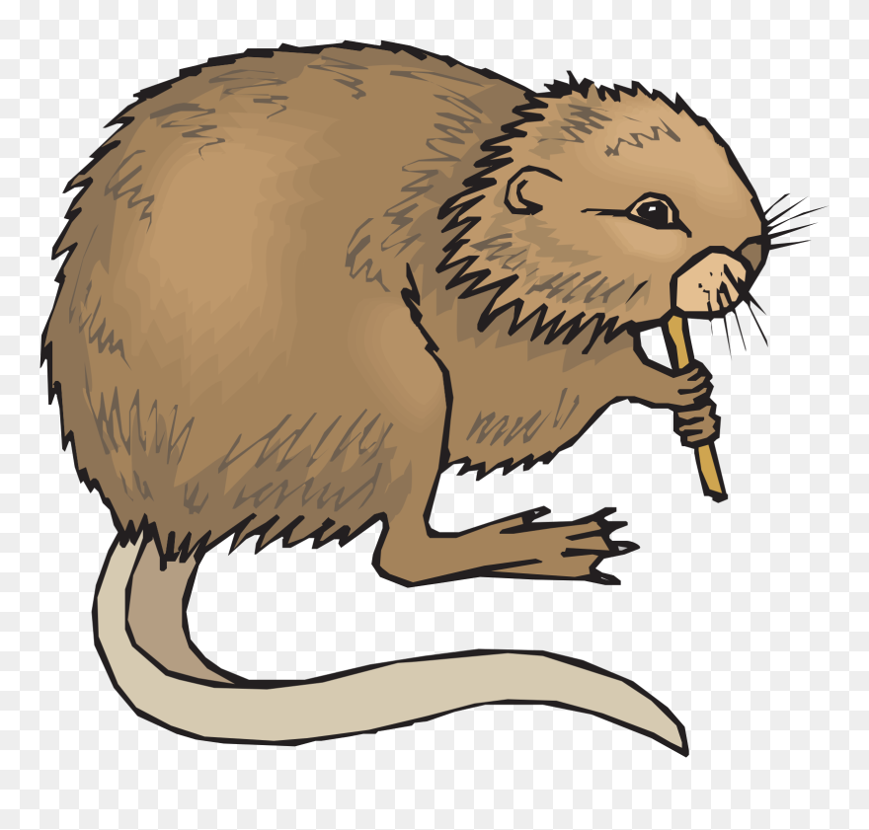 | sq'élhq'elh |  | 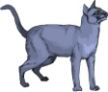 | pú:s / pelups
 | speláwél |  |  | x̱óqel |  |  | púpso:llh
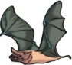 | peth’láxel / p'íp'eth'láxel |  |  | sqwíqw |  |  | th'éxtel / th'éx̲th'éx̲tel
 | skoyám |  | 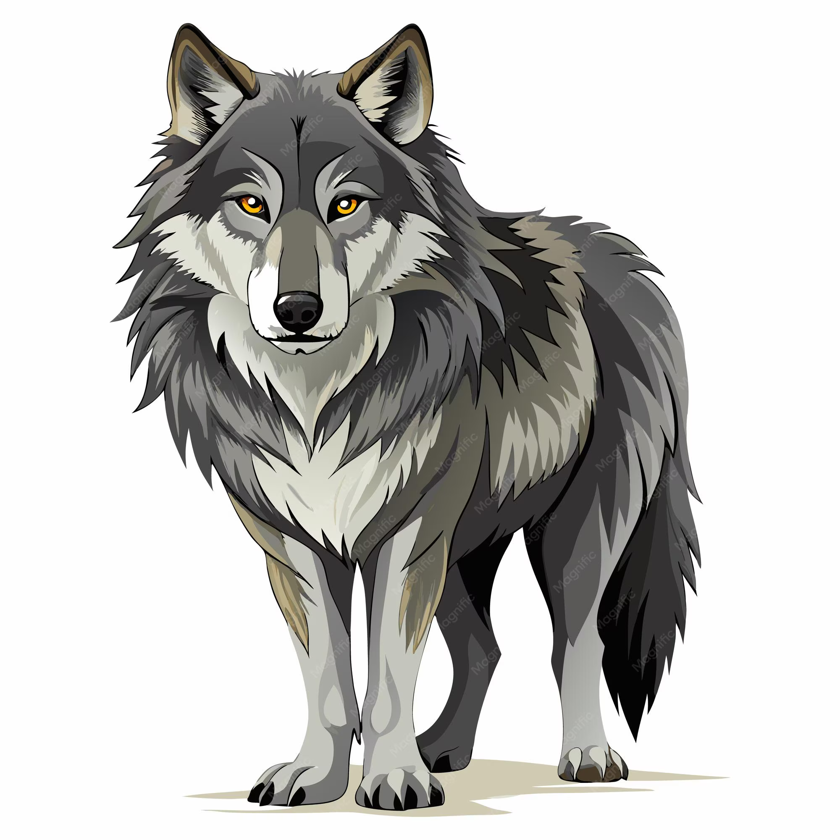 | steqóye / stelqóye |  | 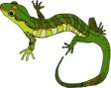 | pítxel / petpítxel
 |  |  |  | sqáyéx̱

1. |  |  | 2. |  |  | 3.
4. | 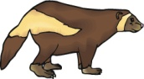 |  | 5. |  |  | 6.
7. |  |  | 8. |  |  | 9.
10. |  |  | 11. |  |  | 12.

Vocabulary 2
Instructions With your partner, ask and answer questions about animals. Follow the model.

example 1: A: li ts'íts'etxel te pítxel?
C: a’a, ts'íts'etxel te pítxel.

example 2: A: li ts'íts'etxel te pú:s?
C: éwe is ts'íts'etxel te pú:s.

 | sq'átl' |  |  | shxwémetsel |  |  | mél:és
 | swatíya |  |  | sq'élhq'elh |  |  | pú:s
 | speláwél |  |  | x̱óqel |  |  | púpso:llh
 | peth’láxel |  |  | sqwíqw |  |  | th'éxtel
 | skoyám |  |  | steqóye |  |  | pítxel
 |  |  |  | sqáyéx̱

Vocabulary 3
Instructions With your partner, ask and answer questions about animals. Follow the model.

example 1: A: li qw'x̲wéltses te púpso:lhs?
C: a’a, qw'x̲wéltses te púpso:lhs.
example 2: A: li qw'x̲wéltses te th'éx̲tels?
C: ewéta qw'x̲wéltses te th'éx̲tels.

(don’t forget the -s at the end of the animal word!)
 | sq'átl' |  |  | shxwémetsel |  |  | mél:és
 | swatíya |  |  | sq'élhq'elh |  |  | pú:s
 | speláwél |  |  | x̱óqel |  |  | púpso:llh
 | peth’láxel |  |  | sqwíqw |  |  | th'éxtel
 | skoyám |  |  | steqóye |  |  | pítxel
 |  |  |  | sqáyéx̱

1. | 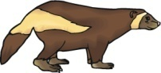 |  | 2. |  |  | 3.
4. |  |  | 5. |  |  | 6.
7. | 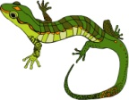 |  | 8. | 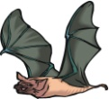 |  | 9. | 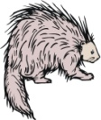

vocabulary 4
Instructions With your partner, ask and answer questions about animals. Follow the model.

example 1: A: li t’óp’els te láqleqems?
C: a’a, t’óp’els te láqleqems.
example 2: A: li t’óp’els te skoyáms?
C: ewéta t’óp’els te skoyáms.

(don’t forget the -s at the end of the animal word!)
 | sq'átl' |  |  | shxwémetsel |  |  | mél:és
 | swatíya |  |  | sq'élhq'elh |  |  | pú:s
 | speláwél |  |  | x̱óqel |  |  | púpso:llh
 | peth’láxel |  |  | sqwíqw |  |  | th'éxtel
 | skoyám |  |  | steqóye |  |  | pítxel
 |  |  |  | sqáyéx̱

1. |  |  | 2. |  |  | 3.
4. |  |  | 5. |  |  | 6.
7. |  |  | 8. |  |  | 9.
10. |  |  | 11. |  |  | 12.

grammar 1
Instructions The class has just returned from a field trip to Yale. With your partner, re-enact the conversations among students and their friends about what they saw.

example 1: A: Lichexw kw’etslexw kw’e shxwémetsel?
C: a’a, tsel kw’etslexw kw’e shxwémetsel.

 | sq'átl' |  |  | shxwémetsel |  |  | mél:és
 | swatíya |  |  | sq'élhq'elh |  |  | pú:s
 | speláwél |  |  | x̱óqel |  |  | púpso:llh
 | peth’láxel |  |  | sqwíqw |  |  | th'éxtel
 | skoyám |  |  | steqóye |  |  | pítxel
 |  |  |  | sqáyéx̱

1. |  |  | 2. |  |  | 3.
 | Tl’eléwe |  |  | Tl’eléwe qas te |  |  | q'á:lemi
4. |  |  | 5. |  |  | 6.
 | Tl’a’altha qas ye swóweles |  |  | yutl’ólem |  |  | Tl’eléwe qas Teqwotenot
7. |  |  | 8. |  |  | 9.
 | Tl’a’altha |  |  | Qwoqwel qas tl’eléwe |  |  | Sotmietel qas qe'óleqs

grammar 2

Instructions A hunter has stopped by the class camp in Yale to brag about their kills. With your partner, re-enact the conversations among the hunter and students.

example 1: A: lí kw’etslexwes te shxwémetsel lil sxelxcha?
C: a’a’, kw’etslexwes.

example 2: A: líchexw kw’etslexwes te méles lil sxelxcha?
C: a’a, tsel kw’etslexw

 | sq'átl' |  |  | shxwémetsel |  |  | mél:és
 | swatíya |  |  | sq'élhq'elh |  |  | pú:s
 | speláwél |  |  | x̱óqel |  |  | púpso:llh
 | peth’láxel |  |  | sqwíqw |  |  | th'éxtel
 | skoyám |  |  | steqóye |  |  | pítxel
 |  |  |  | sqáyéx̱

1. |  |  | 2. |  |  | 3.
 | Tiliyen qes S:wlsh |  |  | ta’á’altha |  |  | Telewe qas Sotmítetel
4. |  |  | 5. |  |  | 6.
 | Ye swíyeqe |  |  | Lōs |  |  | Teléwe qas tha’ sq’áq
7. |  |  | 8. |  |  | 9.
 | Teléwe |  |  | Kóyalemot qas teléwe |  |  | Lóli qas te síyayes

Dialogue

Íwesá:ls: Re-enact the conversation between Susal and her méle, Kim.
S: qélémex!
K: Kwá xwe'ít kwá, méle?!
S: qélémex! sq'óq'ey mekw’ ye chékel!
K: stám?!? sq'óq'ey ye chékel?!
S: a’a, the’ít! qélémex!
K: mílha kw'e lò. Héyathla kw’átset.

téx̲w...
S: xwe’ít, tal?
K: tsel lhq'élexw we tewátes kw'e xt'ástxw tethá! Kw’e sqets'ómes!
S: Stám tethá, sqets'ómes?
K: hikw pus kw’e sqets'ómes.
S: li sta’a kw’e shxwúwe?
K: a’a, qe yeláwel axwil.
S: li qw'x̲weltses kw’e sqets'ómes?
K: a’a’, qw'x̲weltses kw’e sqets'ómes.
S: eystexwes kw’e sqets'ómes ye chekel!
K: a’a, méle. Sta’a talhímelh! Ts’ats’eltset ew éystexw kw’e chekel!

grammar worksheet

A. Intransitive Description
Instructions rewrite each sentence in the opposite. Then, translate the new sentence to Xwelítemqel̓.

1. éwe is ts'íts'etxel te pú:s. ______ ts'íts'etxel te pú:s.
Xwelítemqel̓: a cat is short legged.
2. Ewe is tl’aqt te stl'ep'élets te speláwéls. _____tl’aqt te stl'ep'élets te speláwéls
Xwelítemqel̓: A mole has a long tail.
3. t’óp’els te skoyáms. _______ewéta t’óp’els te skoyáms
Xwelítemqel̓: a wolverine doesn’t have a beak
4. qw'x̲wéltses te th'éx̲tels. _______ewéta qw'x̲wéltses te th'éx̲tels.
Xwelítemqel̓: a rattlesnake doesn’t have claws.
5. tl’aqt te stl'ep'élets te swatíyas. ____Ewe is tl’aqt te stl'ep'élets te swatíyas.
Xwelítemqel̓: A porcupine doesn’t have a long tail
6. t’óp’els te sqwíqws . ______ewéta t’óp’els te sqwíqws.
Xwelítemqel̓: A groundhog doesn’t have a beak
7. ts'íts'etxel te steqóye _____éwe is ts'íts'etxel te steqóye
Xwelítemqel̓: A wolf doesn’t have short legs
8. qw'x̲wéltses te pítxels. _________ewéta qw'x̲wéltses te pítxels.
Xwelítemqel̓: a lizard doesn’t have claws
9. t’óp’els te púpso:llhs. ____________ewéta t’óp’els te púpso:llhs.
Xwelítemqel̓: a kitten doesn’t have a beak
10. tl’aqt te stl'ep'élets te ts'ésqels. _______Ewe is tl’aqt te stl'ep'élets te ts'ésqels.
Xwelítemqel̓: a golden eagle doesn’t have a long tail
C. kw'átset
Instructions fill in the blank with the most appropriate form prompted by the Xwelítemqel̓ in parentheses. Then, translate the sentence to Xwelítemqel̓.

1. ____tsel kw’átset _____te pús. (I look at)
Xwelítemqel̓: I looked at the cat
2. ____ilhtset kw’átset _____te hikw petpítxel. (we look at)
Xwelítemqel̓: We looked at the big lizards.
3. táta,____ kw’átsethóx____! (you look at me)
Xwelítemqel̓: Mom,look at me!
4. ____kw’átsetchap____ tethá smált, telí le xw’eí te skoyám. (y’all look at)
Xwelítemqel̓: (Y’all) look at the mountains there, that’s where the wolverine came from
5. le ____ kw’átsetes ____te pítxel. (it looks at it)
Xwelítemqel̓: The lizard looked at it.
6. le ____ kw’átsetes ____te méle. (they look at it)
Xwelítemqel̓: They looked at the child.
7. ____ilhtsel kw’átset ____te sp’áq’em mekw’ tlátelh. (I look at it)
Xwelítemqel̓: I looked at the flower all morning,
8. ____tset kw’átset _____te slíts' skw'exó:s xweláltelh. Le xwe iyómex. (we look at it)
Xwelítemqel̓: We all looked at the full moon last night. It was beautiful
9. ___kw’átsetóxchap_____lhit tl'xwéleq te hélme’als pol sewólem. Ilhtsel xwoyíwel (y’all look at me)
Xwelítemqel̓: Y’all looked at me when we won that soccer game. I was happy.
10. ____éwe kw’átsetes ____te kwósel tl’ó kw’es ólu x̲lhém. (they look at them)
Xwelítemqel̓: They didn’t look at the stars because they were too tired.

