Lesson 20: kitchen and cooking 1
sqwal 1
singular | plural
shxwqwó:ls | *** | pot (for boiling)
lhémkiya | lhemlhémkiya | big iron pot
shxwts'ákwx̲els | *** | frying pan
lháts’tel | lhá:lets'tel | knife
x̲álew | *** | serving spoon
shxwqwáylhecháls | *** | long handled stirring spoon
lóthel | lelóthel | dish / pan/tray
skw'ówes | *** | bucket, kettle
s'áp'wí:ls | *** | dish towel / tea towel
q'ex̲q'x̲el | *** | (tin) can
kwéltsestel | *** | oven mitt / potholder
sqélqelepálá | *** | garbage can
shxwémeqéyls | shxemxwemeqéyls | can opener

sqwéltel 2
to…. | …ing
th’ex̱wíls | th’óx̱wils | wash dishes
hóy | hihóy | finish
hóythel | hóyethel | finish eating
óxwest | ó:xwest | give something to someone
qéylemt | qeyqelémt | put it away
sqwéltel 1
áletse te shxwémeqéyls? | Where is the can opener?
Óxwestóxchexw te shxwémeqéyls. | Give me the can opener.
áletse te kwéltsestel? | Where is the pot holder?
óxwestóxchexw te kwéltsestel. | Give me the pot holder.
áletse te shxwqwó:ls? | Where is the pot?
óxwestóx te shxwqwó:ls. | Give me the pot.

Sqweltel 3
Lichexw hóyethel | Are you done eating?
a’a, hóyetheltsel. | Yes, I am done eating.
Lí hóyethel? | Is she done eating?
a’a hóyethel thútl’o. | Yes, she is done eating.
Lichap hóyethel? | Are you all done eating?
a’a, hóyetheltset. | Yes, we are done eating.
Lí hóyethel yutl’ólem? | Are they done eating?
a’a, hóyethel yutl’ólem. | Yes, they are done eating.

Sqwéltel 4
lichxw hoy th’ox̱wíls? | Are you done washing dishes?
a’a ulh tsel hoy th’ox̱wíls. | Yes, I am done washing dishes.
Li hoy th’ox̱wíls thutl’ó? | Is she done washing dishes?
a’a, ulh hoy th’ox̱wíls thutl’ó. | Yes, she is done washing dishes.
lichap hoy th’ox̱wíls? | Are you folks done washing dishes?
a’a ulh tset hoy th’ox̱wíls. | Yes, we are done washing dishes.
iyáqtem te sqwal
th’ex̱wót | wash something
past/present  transitive | singular | plural
1st person (I / we) | th’ex̱wóttsel | th’ex̱wóttset
2nd person (you / y'all) | th’ex̱wótchexw | th’ex̱wótchap
3rd person (she, he, it / they) | th’ex̱wótes | th’ex̱wótes

Note: you will see different endings on th’ex̱w- (wash) for some ‘things’ being washed, for example -ils for dishes, -átseses for hands, -éles for teeth, etc.

xwe’íts:
th'exwót qe éwechxw ts'áyxwtexw. | Wash it but don’t dry it.
Skw'ay kw'els th'exwot te spils s'alhtel. | I can’t wash the vegetables.
th’ex̱wótlha! | Wash it! (sg.)
th’ex̱wótes te lhémkiya. | He washed out the big pot.

qéylemt | to put something away
past/present  transitive | singular | plural
1st person (I / we) | qéylemttsel | qéylemttset
2nd person (you / y'all) | qéylemtchexw | qéylemtchap
3rd person (she, he, it / they) | qéylemtes | qéylemtes

xwe’ít:
Qéylemtchexw te hóythel s'álhtel! | Put away the leftovers!
qéylemtes yutl’ólem te s'áp'wí:ls. | they put away the dish towel.
éwe tsel il qéylemt te x̲álew. | I didn't put away the serving spoon.
lichap qéylemt te lhá:lets'tel? | Did you guys put away the knives?

Sqwal 1
Iwesá:ls With your partner, practice asking and answering questions in the kitchen. Follow the model.

A: alétse te shxwémeqéyl?
B: íkw’elō!
A: óxwestóxchexw te shxwémeqéyl.
B: kwútchexw te shxwémeqéyl.

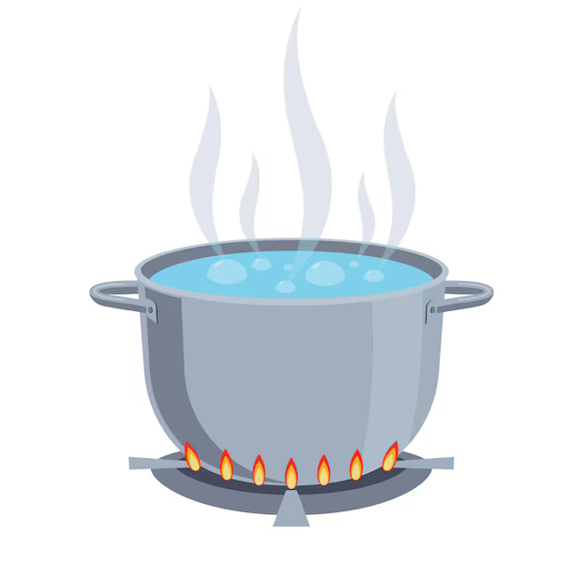 | shxwqwó:ls |  | 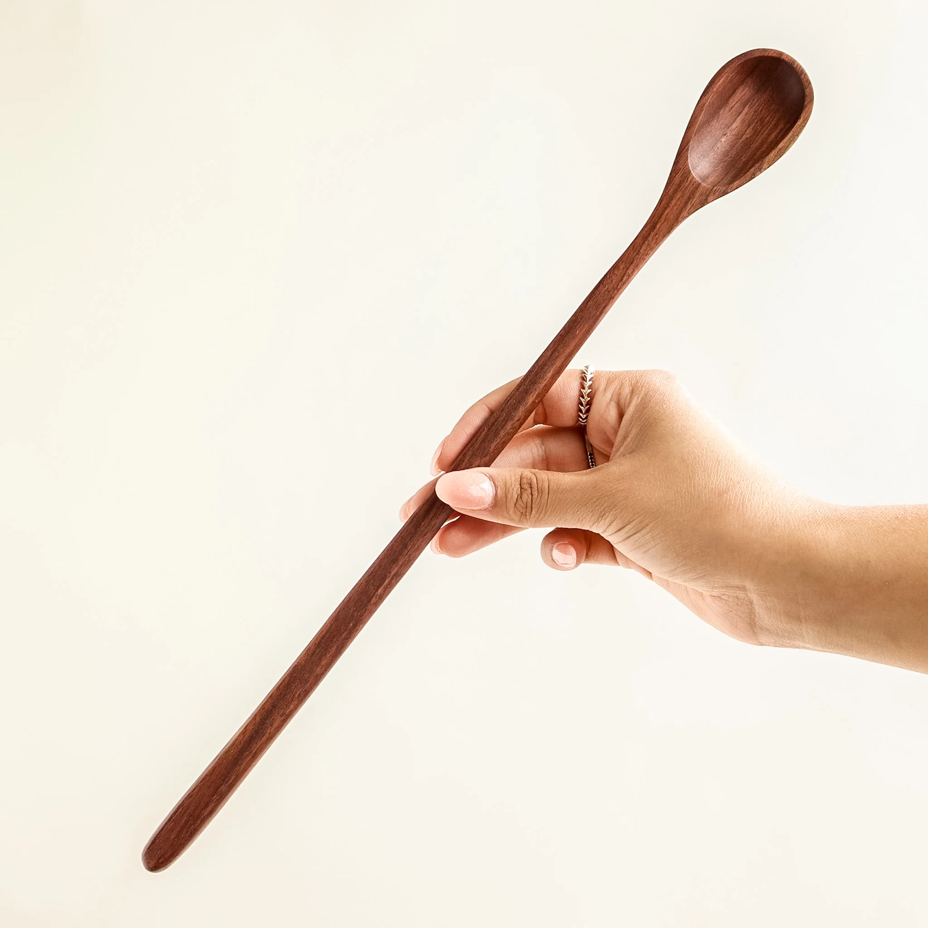 | shxwqwáylhecháls |  | 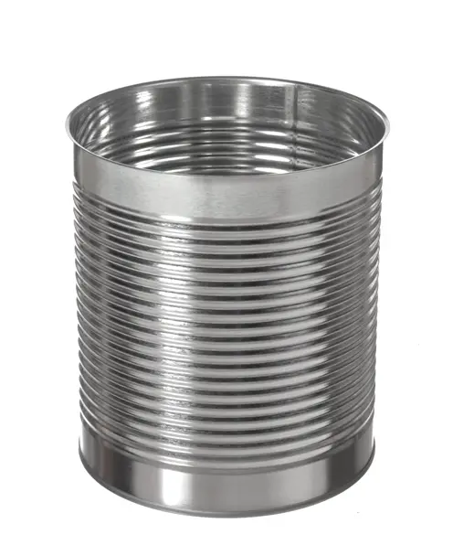 | q'ex̲q'x̲el
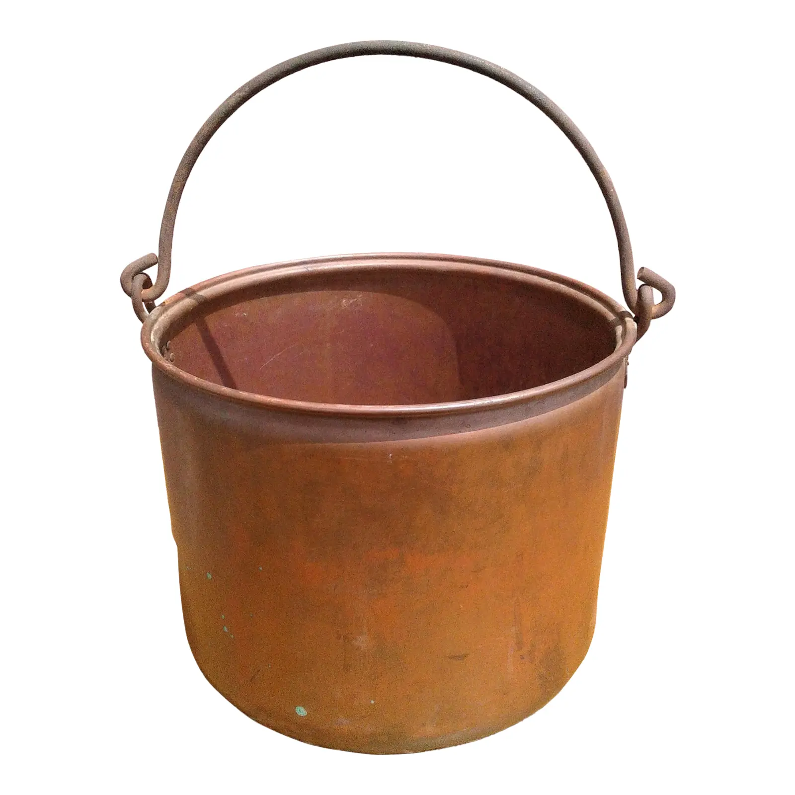 | skw'ó:wes |  | 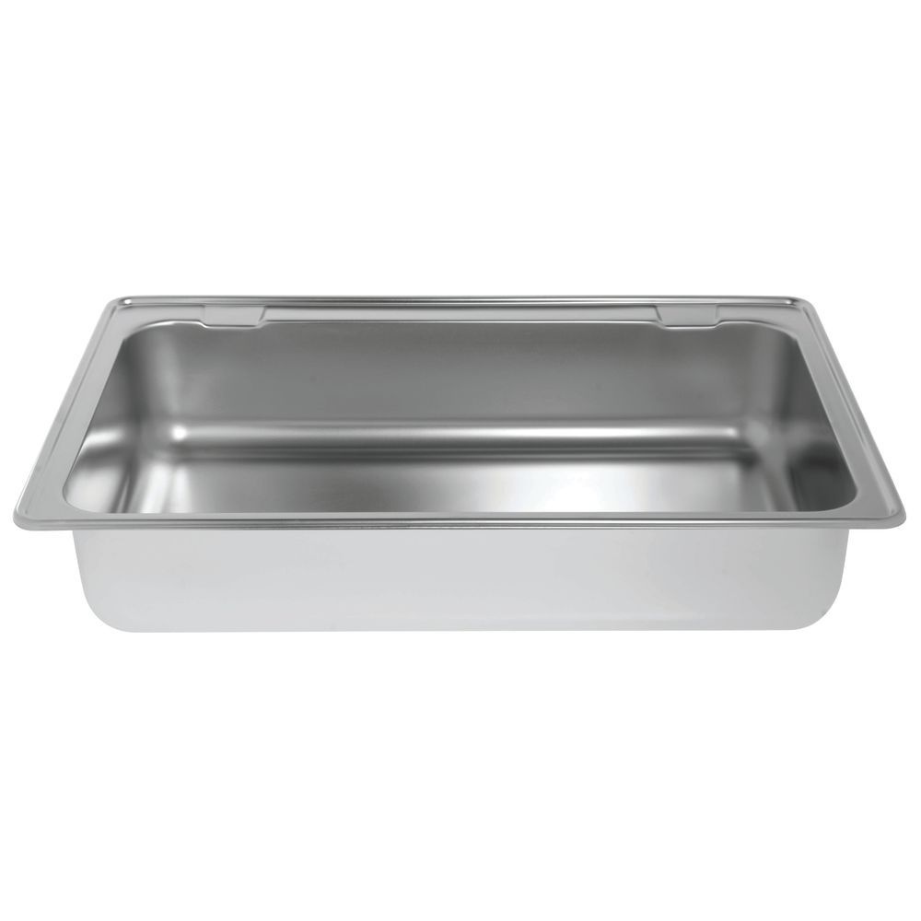 | ló:thel / leló:thel |  | 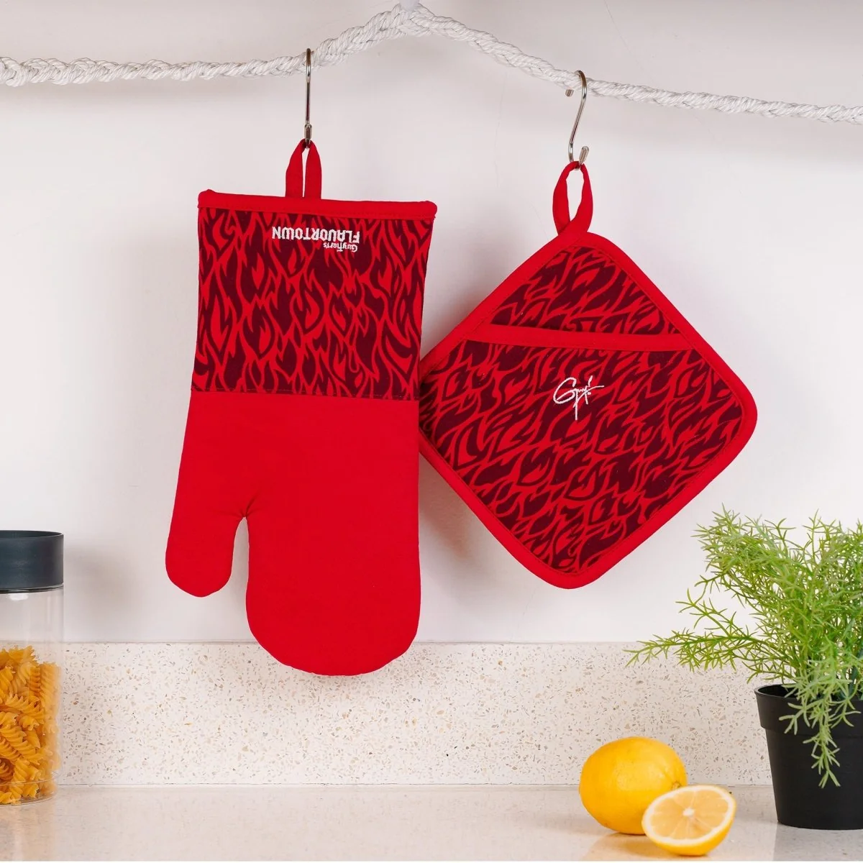 | kwéltsestel
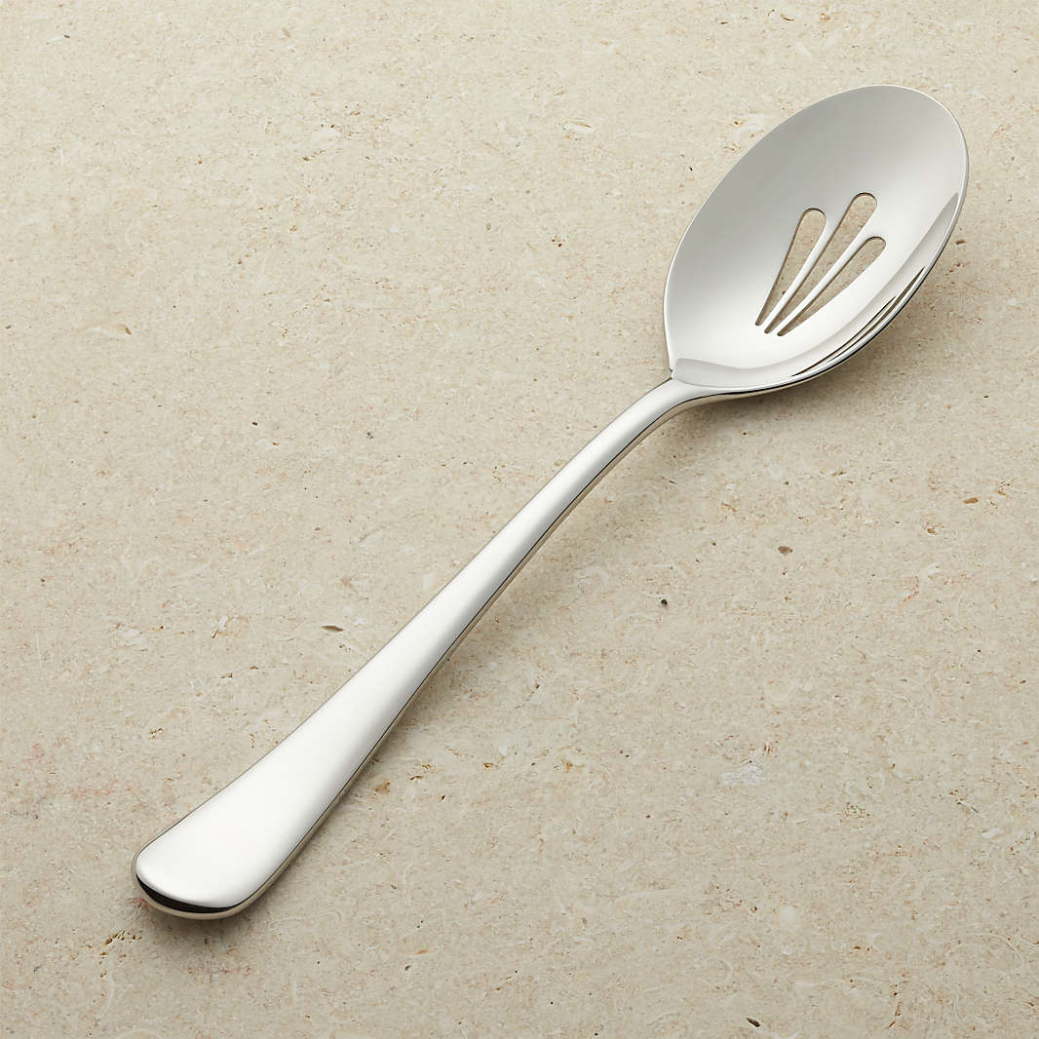 | x̲álew |  | 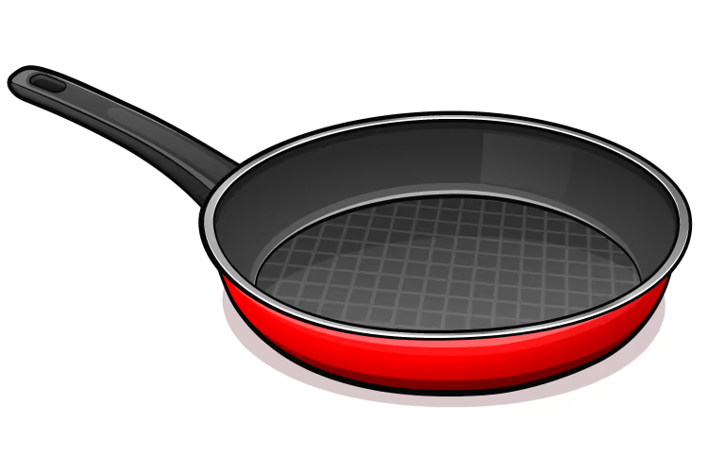 | shxwts'ákwx̲els |  |  | sqélqelepálá
 | Lháts’tel / lhá:lets'tel |  | 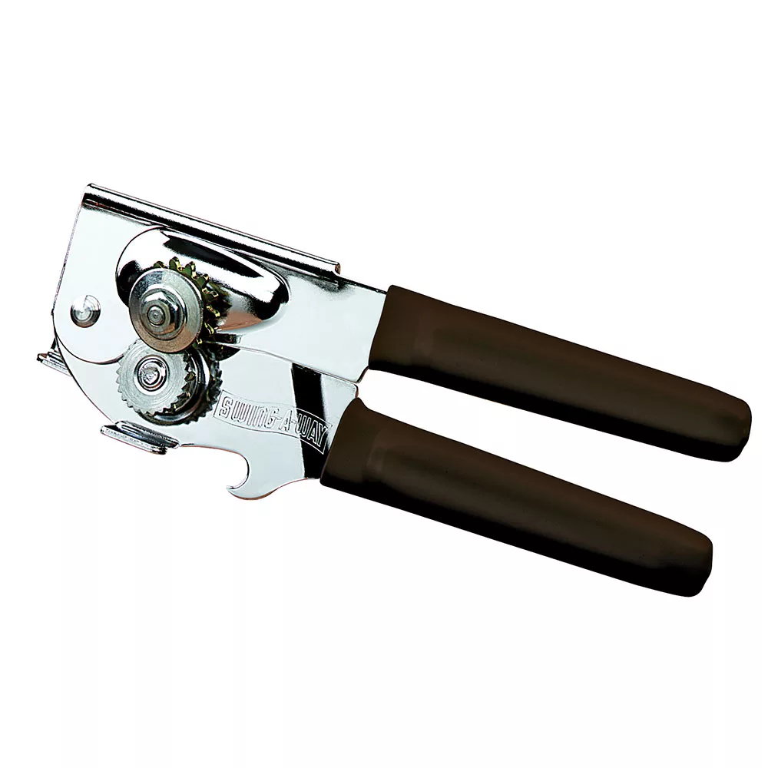 | shxwémeqéyl / shxemxwemeqéyls |  | 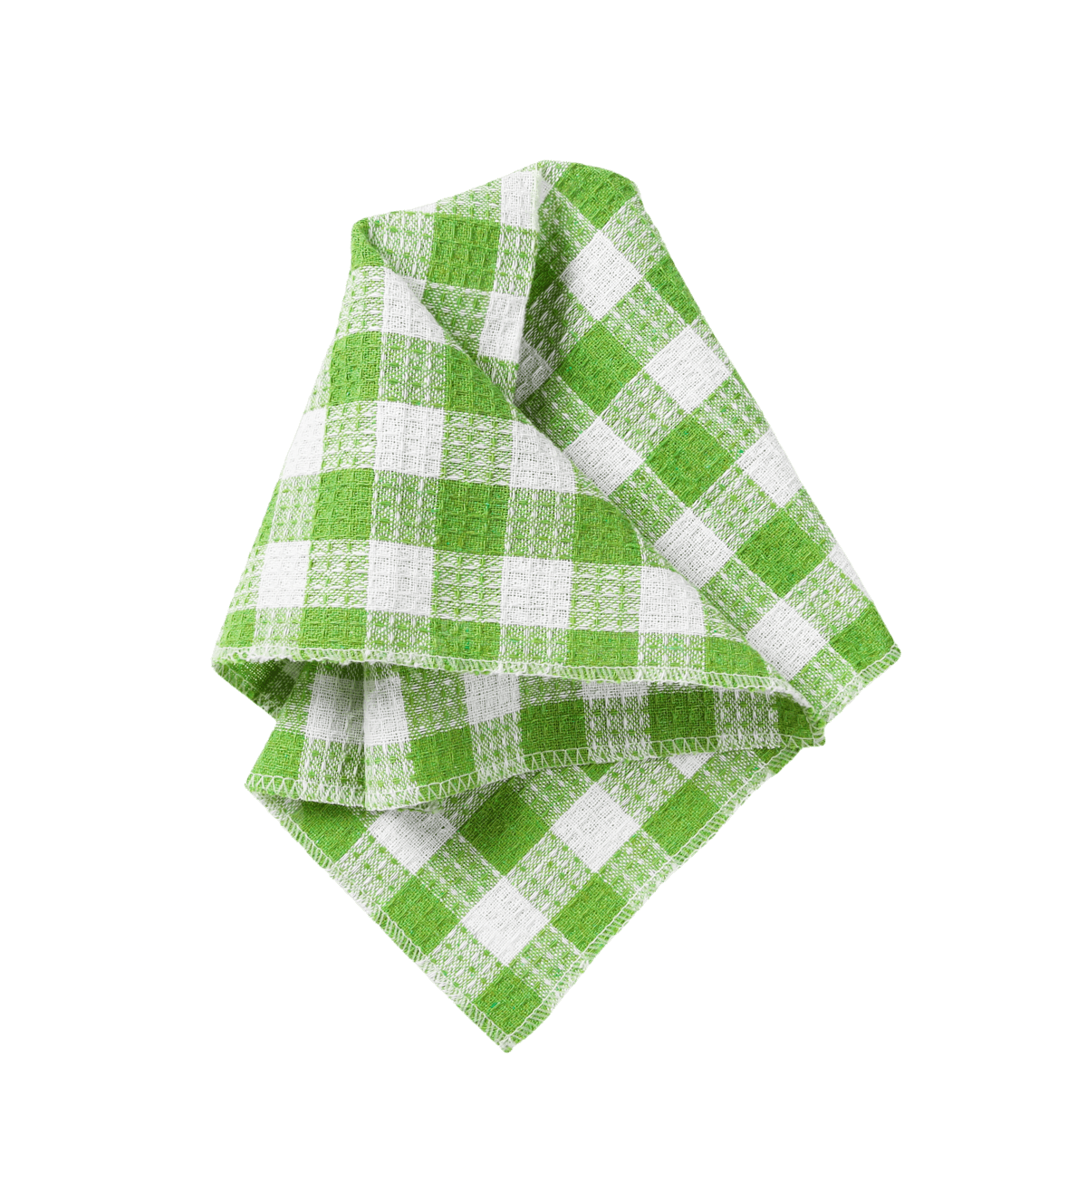 | s'áp'wí:ls
 |  |  | 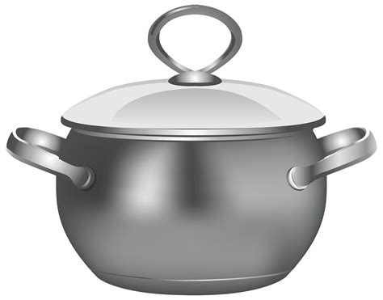 | lhémkiya / lhemlhémkiya

1. |  |  | 2. |  |  | 3.
4. |  |  | 5. |  |  | 6.
7. |  |  | 8. |  |  | 9.
10. |  |  | 11. |  |  | 12.

sqwal 2
Íwesá:ls Qwoqwel is hard-working and always does the dishes. Re-enact his conversation with Plóti. Follow the model.

Stám: Plóti: lichexw hóy th’ex̱wót te shxwts'ákwx̲els?
Qwo: a’a, ulhtsel hóy th’ex̱wót te shxwts'ákwx̲els

 | shxwqwó:ls |  |  | shxwqwáylhecháls |  |  | q'ex̲q'x̲el
 | skw'ó:wes |  |  | ló:thel / leló:thel |  |  | kwéltsestel
 | x̲álew |  |  | shxwts'ákwx̲els |  |  | sqélqelepálá
 | Lháts’tel / lhá:lets'tel |  |  | shxwémeqéyl / shxemxwemeqéyls |  |  | s'áp'wí:ls
 |  |  |  | lhémkiya / lhemlhémkiya

1. |  |  | 2. |  |  | 3.
4. |  |  | 5. |  |  | 6.
7. | 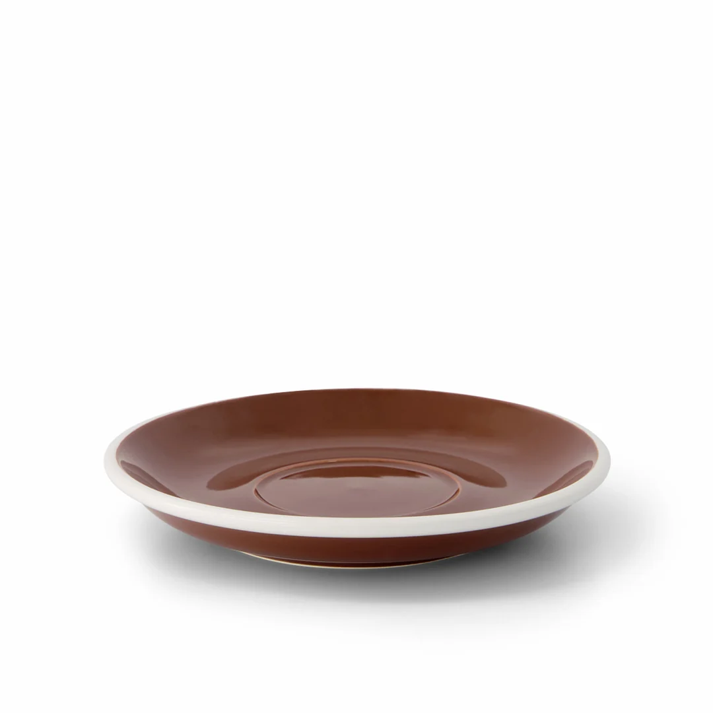 |  | 8. |  |  | 9.

Iaqtem te sqwal 1
Iwesá:ls Samiyonsiya and Tuxwotenot are preparing a big dinner. Re-enact their conversation about what they and their helpers have done . Follow the model.

Xwe’ít 1: Samiyonsiya: lichexw th’ex̱wót te xwelítemelh sokw?
Tuxwotenot: a’a. ilhtsel th’ex̱wót te xwelítemelh sokw.

Xwe’it 2: Samiyonsiya: li th’ex̱wótes te Táta qes te Wílelot ye kwx̲wómels?
Tuxwotenot: A’a, th’ex̱wótes te Táta qes te Wílelot ye kwx̲wómels.

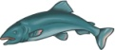 | kwōx̲weth |  | 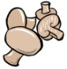 | q'ém:és |  | 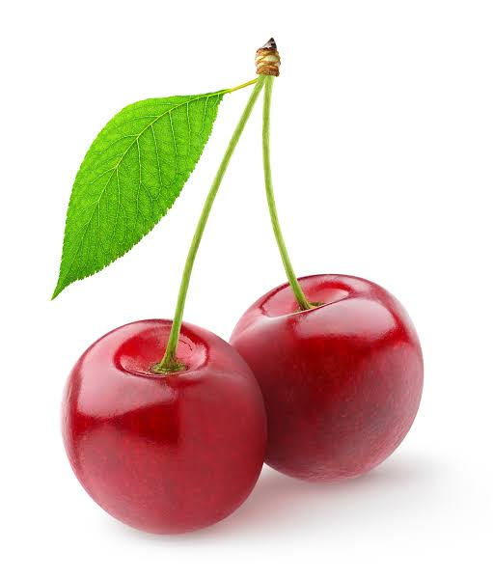 | chalís
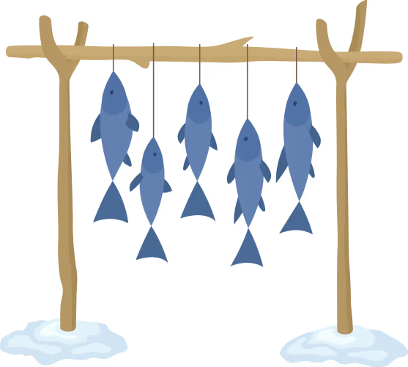 | slhíts'es |  | 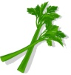 | xwelítemelh sókw |  | 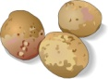 | sqá:wth
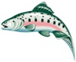 | sth'qwá:y |  | 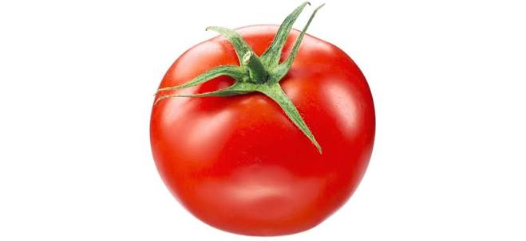 | tomítō |  |  | s'ó:ytheqw
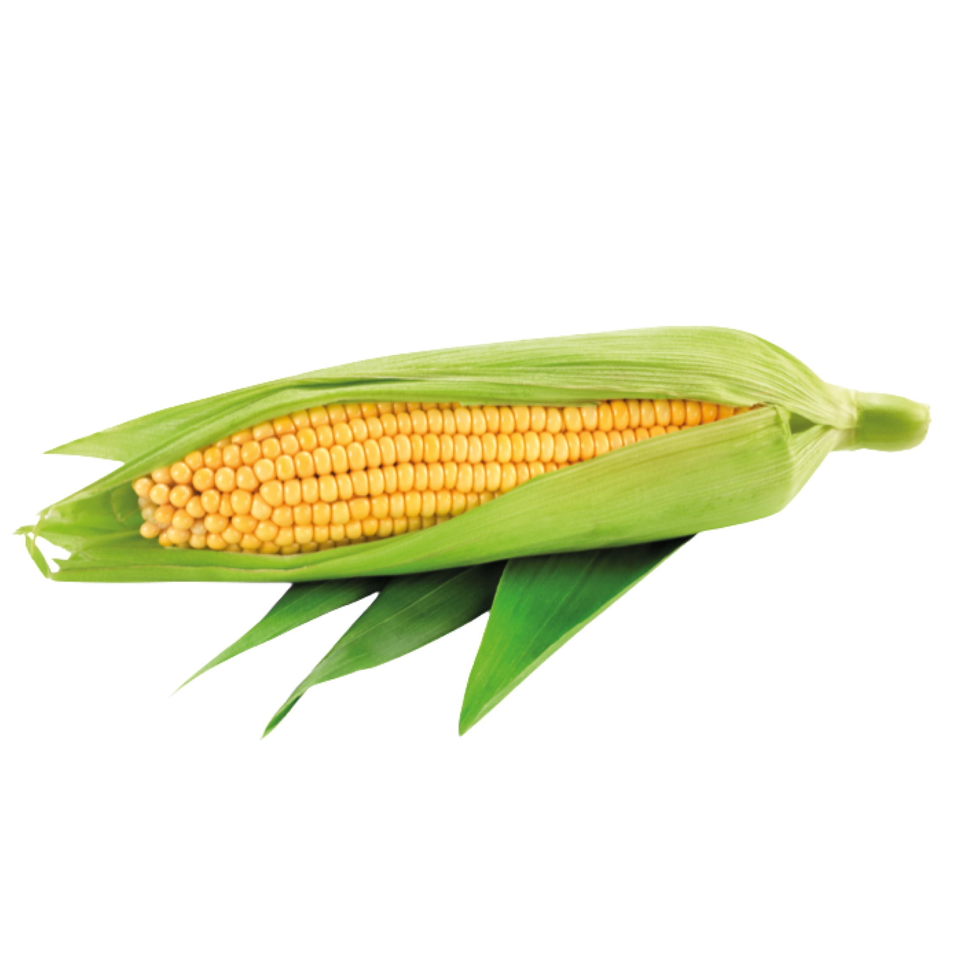 | kwól |  |  | kwx̲wómels |  | 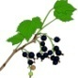 | ts'esláts

1. | 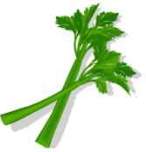 |  | 2. |  |  | 3.
 | chexw |  |  | Táta qes Wílelot |  |  | Qwoqwel
4. | 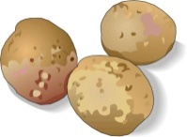 |  | 5. | 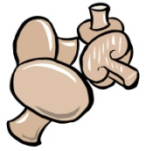 |  | 6. | 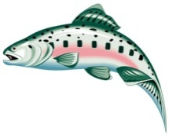
 | Swolésiya |  |  | Tlelewe qas Plóti |  |  | Kuyalemot qas Tilyel
7. |  |  | 8. | 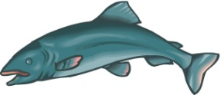 |  | 9.
 | chexw |  |  | Kwetó:liya |  |  | Tlelewe qas Táta

Iaqtem te sqwal 2
Iwesá:ls Kuyalemot and Swolésiya are cleaning up after a big dinner. Re-enact their conversation about what they and their helpers have done. Follow the model.

xwe’ít 1: Kutalemot: líchexw qéylemt
Swolésiya: a’a tsel qéylemt te shxwts'ákwx̲els.
xwe’ít 2: Kuyalemot: lí qéylemtes te Pít qes te Máli te s'áp'wí:ls?
Swolésiya: a’a. qéylemtes te Pít qes te Máli te s'áp'wí:ls.

 | shxwqwó:ls |  |  | shxwqwáylhecháls |  |  | q'ex̲q'x̲el
 | skw'ó:wes |  |  | ló:thel / leló:thel |  |  | kwéltsestel
 | shxwts'ákwx̲els |  |  | lhémkiya / lhemlhémkiya |  |  | sqélqel:epálá
 | Lháts’tel / lhá:lets'tel |  |  | shxwémeqéyl / shxemxwemeqéyls |  |  | s'áp'wí:ls
 |  |  |  | x̲álew

1. |  |  | 2. |  |  | 3.
 | chexw |  |  | Pít qas te Malí |  |  | Telewe qas Sulisulwut
4. |  |  | 5. |  |  | 6.
 | Pō:wan qas Lóli |  |  | chexw |  |  | Táta
7. |  |  | 8. |  |  | 9.
 | Pípte |  |  | Tlelewe qas Semeonsiya |  |  | Tilien qas Seqwamiya

Dialogue
Iwesá:ls Re-enact the conversation between Susal and her son, Pít, as they work together to make supper.

S: Pít, emíkw’elo!
P: stám?
S: emíkw’elo, máythóx
P: stám kw'e stl'í?
S: Lichexw hoy th’ox̱wíls xweláltelh?
P: éwe, Ilhtsel olú x̲elhém.
S: osu th’exwílschexw tl’oqays.
P: iyólem.

téx̲w

S: xwe’ítsel tloqays?
P: lichxw hoy th’ox̱wíls?
S: a’a, a’a ulh tsel hoy th’ox̱wíls.
P: iyólem, éy. Li tethá te shxwts'ákwx̲els.
S; a’a, ikw’elō, qe xwel chmitl’.
P: óxwestoxchexw. th’ex̱wóttselcha
S: Lí ew iyólem kw'els máythóme?
P: éwe, híhoytchexw ta‘ syoys. Ts’íthóme, méle.
S: a’a’áwelh tal.

Translation:
S: Pít ! Come here !
P: What ?
S: Come here ! Help me !
P: What do you want?
S: Did you finish washing the dishes last night ?
P: No. I was too tired.
S: Well, wash it out now.
P: Ok.
Later..
P: And what am I doing now ?
S: Did you finish washing dishes?
P: Yes. I finished washing dishes.
S: Good. Is the frying pan there?
P: Yes. But it’s dirty.
S: Give it to me. I will wash it.
P: Can I help you?
S: No. You are done working. Thank you, my son.
P: Your welcome, Mother.

Grammar Worksheet

A. th’ex̱wót
Iwesá:ls complete each sentence with the form indicated in (). Then translate to Xwelítemqel.

- ____Ilhtsel th’ex̱wót____ te shxwts'ákwx̲els cheláqelh. (I washed)
Xwelítemqel: I washed the frying pan yesterday
- ____th’ex̱wóttsetcha____ te lhemlhémkiya yeláw te xwelált althel. (we will wash)
Xwelítemqel: We will wash the big iron pots after dinner
- Li ___chexwcha th’ex̱wót _____thethá lhá:lets'tel? (will you wash)
Xwelítemqel: are you washing those knives?
- ____th’ex̱wótchap_____ te q'ex̲q'x̲el qes te shxwémeqéyls. (y’all wash)
Xwelítemqel: (y’all) wash the can and the can opener.
- ____Éwe is th’ex̱wótes_____ ta’ álex te x̲álews. (he didn’t wash)
Xwelítemqel: your brother didn’t wash his spoon
- _____th’ex̱wótescha ______te skw'ó:wes wáyeles. (she will wash)
Xwelítemqel: She will wash the bucket tomorrow
- _____th’ex̱wótes____ te shxwewális mekw’ te leló:thel. Temq’áq’et’em tloqáys! (they washed)
Xwelítemqel: his parents washed all the dishes. now it’s time for dessert.
- ____éwetset th’ex̱wótet _____te kwéltsestel, ewe is chmitl’. (we are not washing)
Xwelítemqel: we are not washing The oven mitt, it is not dirty
- ____th’ex̱wótes _____te stíwels mekw’ ye sqá:wth. (she is washing)
Xwelítemqel: Her niece is washing all the potatoes.
- _____th’ex̱wóttset _______te skw'ó:wes qelát, we’lis ta’ stl’i. (we will wash)
Xwelítemqel: We will wash the kettle again, if that’s what you want

B. qéylemt
Iwesá:ls complete each sentence with the form indicated in (). Then translate to Xwelítemqel.
- __éwetselcha qéylemt____ te s'áp'wí:ls, l stl’i. (I put away)
Xwelítemqel: I will not put away the towel, I need it.
- ulh tset hoy th’ox̱wíls qes____qéylemttset____. (we put away)
Xwelítemqel: we finished washing the dishes and put them away.
- _____qéylemtchexw_____te lháts’tel (you put away)
Xwelítemqel: Put the knife away.
- Hoytset te syoystset, ____qéylemtchap____ ta’ púkwchap. (y’all put away)
Xwelítemqel: we are done working, put away your books.
- Li ____qéylemtes_____te shxwémeqéyls? Éwetsel il kwélexw. (he puts away)
Xwelítemqel: Did he put the can opener away? I cannot find it
- Ewálh ____qéylemtes___ tutl’o te awkw’s. (she puts away)
Xwelítemqel: He never puts away his clothes.
- Alétse te hxwts'ákwx̲els? Li ____qéylemtes___ yutl’ólem? (they put away)
Xwelítemqel: Where is the frying pan? Did they put it away?
- th’ex̱wóttset te x̲álew, qesu ts'íyxwttset qes qéylemttset. (we put away)
Xwelítemqel: we wash the serving spoon, then we dry it, then we put it away
- ____éwe is qéylemtescha____ Semeonsiya te lóthels, skwól swáyels tloqays. (she will not put away)
Xwelítemqel: Semeonsiya will not put away her plate today, it’s her birthday
- Qéylemtlha ta’ shxwtatím! Heythl ewolem helme’als pol! (put away!!! -sg)
Xwelítemqel: (you) put the phone away and let’s go play soccer!

